NEWSLETTER
Helping you keep your pet looking, feeling and smelling great!
Tel: 01446 751616 / 07974 720022
Website: www.hairybarkersdogwash.weebly.com
Facebook: www.facebook.com/HairyBarkersDogWash
Twitter: www.twitter.com/HairyBarkers

Issue 1 MARCH 2013
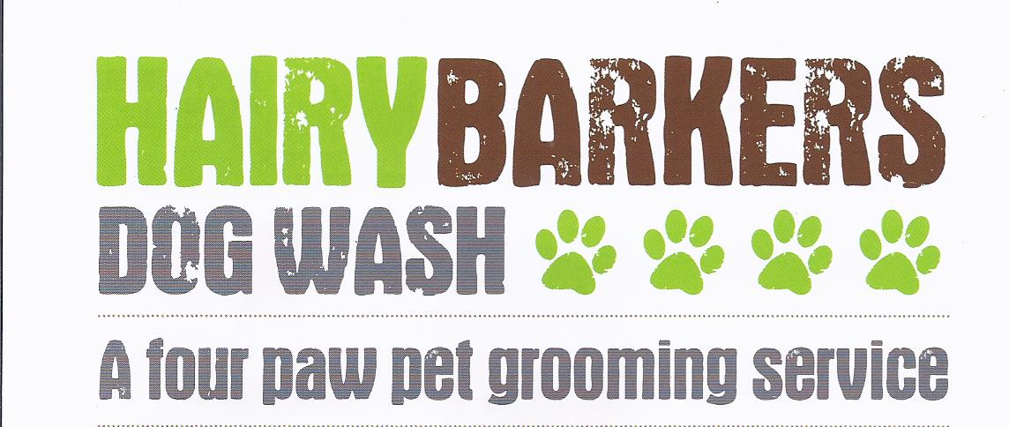
In This Issue:
Happy Mothers’ day!
Featured Pet of the month
Grooming Tips
Low Fat Dog Treat Recipe
Dog Quotes
Spotting Springtime Symptoms

10 March 2013 Is the day to honour all mums great and small!!
Check out this link to a fantastic You Tube Video which sums up a mums day! Guaranteed to put a smile on your face!

What You Need to Know About Flea Season
Fleas can not only make your pet very uncomfortable, they can also make them extremely ill. Flea bites can cause anything from an allergic reaction to more serious complications.
If you're wondering if your pet has fleas, look for these warning signs:
- Extreme scratching and restlessness
- Flea dirt - Using a flea comb that you can buy at any pet store, comb through your pet's coat. If little black specks are picked up on the comb, this may be flea dirt. You can test this by putting the "dirt" on a white paper towel and dampen it. If the specks change to a red or brownish colour, it is probably flea dirt. If you do not have a flea comb, you can place a white paper towel under your pet and run your hand across the fur. The little black specks that appear on the paper towel will change colour as mentioned previously.
Prevention is always better than cure, check your pets flea/worm treatments are up to date, its so easy to miss a treatment, so remember to put a reminder on the calendar. There are a wide range of anti-flea products on the market but if you have any concerns, always check with your vet, who will be able to advise on the best product to suit your dog, particularly, like mine if they enjoy crunching the occasional slug/snail, as they are at risk of getting Lung Worm. My preferred treatment for my own 3 dogs is Advocate, a monthly, combined spot-on treatment, prescribed by my vet, which covers all my dogs needs. Be sure to treat your house with flea sprays as a precaution if fleas are spotted on your pet. The adult fleas on your dog will be killed by your anti-flea product but will soon be replaced by the fleas hatching in his bedding and in your carpet and soft furnishings.
If you do find fleas on your dog, we do offer flea baths. Feel free to contact us and we can get your pet in as quickly as possible.

FEATURED PET OF THE MONTH
FYNN
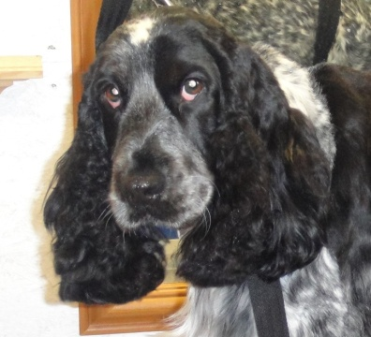
has been a part of the Hairy Barkers family since, well the beginning! He is always a joy to groom and has a very gentle, kind nature. Many Thanks to his devoted owners for letting us be a part of his life. We can’t wait to see you each week.

“Dogs are not our whole lives, but they make our lives whole”
Tel/Fax: 01446 751616
Mobile: 07974 720022

We celebrate on the 31 March this year, but while we all enjoy a treat or two at this time, please remember that chocolate can be toxic to dogs. Why not treat your cuddly companion to a homemade healthy treat instead!

Low Fat Carrot Dog Treats
Ingredients:
1 med ripe banana
1 cup shredded carrots
1/4 cup unsweetened apple juice
1/8 cup water (maybe more, as needed)
1 1/2 cup whole wheat flour (keep some handy for rolling)
1 cup rolled oats
March Madness
To celebrate Spring we are offering 50% Discount off your first grooming session at Hairy Barkers until the 31 March 2013
Start off by preheating your oven to 180 degrees, lightly spraying a baking sheet with nonstick cooking spray and sprinkling a little flour onto the surface you’re planning to use to roll out the dough.
In a medium bowl, mash up the banana and mix in the shredded carrots. To the carrot and banana, add the water and apple juice. Stir. Next, add the oats and flour. Stir all of the ingredients together until they are thoroughly combined.
Using your hands, knead the mixture until a dough forms. Dump the dough onto the lightly floured surface that you prepared earlier. Roll it out until it’s about a half inch thick. Using a cookie cutter (bone shapes are fun!) or the rim of a small glass, cut into 3″ pieces. Place the pieces onto your lightly sprayed baking sheet.
Bake the dog treats for 25 minutes.
Before “serving”, let them cool completely. Here’s a tip that you may find useful: If your dog likes a little more crunch to his treats, then turn off the oven and let the treats cool there overnight.
This recipe makes about 24 low fat, healthy dog treats. My dogs love them, but they’ll actually last about 3 weeks, if stored in the fridge and up to 6 months, if you decide to freeze them.

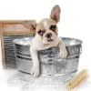

Hairy Barkers Dog Wash

For beautiful grooming performed with kindness and respect

Call Louise Today

01446 751616 / 07974 720022

From: www.dogtreatrecipes.org
GROOMING TIPS
Set aside some time everyday to brush your pet. Not only will it reduce shedding but it will help prevent knots and tangles forming and your pet will love the attention.

Hairy Barkers is proud to have you as a valued customer and looks forward to seeing you again soon. Louise

