National Pet Month 2013
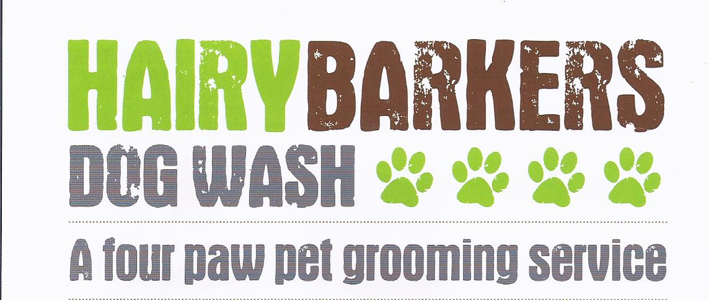
Issue 2 April 2013
NEWSLETTER
Helping you keep your pet looking, feeling and smelling great!
Tel: 01446 751616 / 07974 720022
Website: www.hairybarkersdogwash.weebly.com
Facebook: www.facebook.com/HairyBarkersDogWash
Twitter: www.twitter.com/HairyBarkers

1 April – 6 May

Supporting responsible pet ownership. Find out how you can get involved and be a part of it, at

www.nationalpetmonth.org,uk

******************************************

Seasonal Shedding
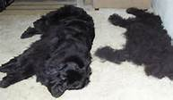
Spring is in the Air!
One of the biggest nuisances faced by pet owners is unwanted hair in their homes. We all love our furry friends, but at this time of year the furry part can be a problem. Your pets may have already begun to shed their winter coats and you may be struggling with the avalanche of fur coming off around the house.
Shedding is a natural process by which dogs lose their existing coat to allow a new coat to come in. It’s Nature’s air conditioning!, preparing your dog for the warmer months ahead. Nearly every dog sheds to some extent, regardless of their age or breed. Breeds considered light shedders such as Poodles, Yorkies, Maltese etc. are usually the breeds that need to be clipped, stripped and or scissored, because their hair falls out at a much slower rate and if they are not properly groomed are prone to matting.
Breeds typically known to be shedders include the Akita, Golden Retriever, Labrador etc. There is no magic cure for the dreaded shed, but to stay comfortable your pet will need your help in getting through this hairy experience. A healthy diet, regular outdoor exercise and routine brushing will help the process pass more quickly and with a lot less mess around the home. Regular brushing will remove the dead and loose coat from your pet and it also stimulates the hair follicles and distributes the skin’s natural oils, providing shine as loose hair and dead skin is removed. Your dog will love you for it and enjoy the added attention they get when they look and feel great!
Or why not give us a call to set up an appointment, even if your dog doesn’t need a haircut. A professional groom is more than just a brush out. Your pet will be thoroughly brushed before being bathed in our Hydrobath with our wonderful shampoos and conditioners designed to aid in the removal of loose coat. This combined with the use of high velocity dryers and correct brushing techniques, will help remove loose hair, which means less to be left on your clothes, furniture and carpets. We’ll make sure his ears are clean, and nails are trimmed before he comes home looking, feeling and smelling grrrr-eat!!!!

In This Issue:
Featured Pet of the month
Grooming Tips
Dog Treat Recipe
Dog Quotes
Happy Earth Day ~ 22 April
National Pet Month ~ 1 April - 6 May 2013
Seasonal Shedding

'Properly trained, a man can be dog's best friend'

FEATURED PET OF THE MONTH

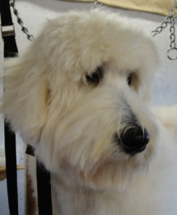
TED has been a regular at Hairy Barkers since puppyhood. It has been a joy to watch him grow into such a handsome boy. Ted is a Labradoodle, who is kept in full coat. His owners do a fantastic job of brushing him out regularly between grooming appointments. I look forward to seeing you again soon Ted!
If your pet has longer hair, proper daily brushing is not just a recommendation, it's a necessity.

Tel/Fax: 01446 751616
Mobile: 07974 720022

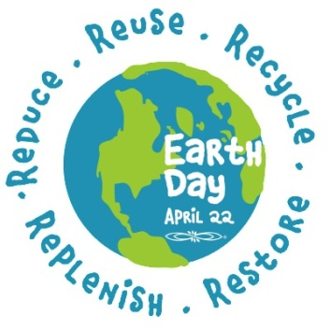
HAPPY EARTH DAY ~ 22 APRIL 2013

To celebrate Earth Day we would like to ask you to recycle your old
towels with Hairy Barkers. As a thank you we will give you 50p/towel towards your grooming appointment.
APRIL SAVINGS
15% DISCOUNT
To Celebrate National Pet Month, new customers will receive 15% discount off their first Full Grooming Service with Hairy Barkers Dog Wash until the 6 May 2013. To take advantage of our 15% Introductory Offer, why not contact LOUISE today to make an appointment, I look forward to welcoming you and your pet soon.
Offer Expires 6 May 2013

GROOMING TIPS
Lightly stroking or gently pulling on the pet’s ear leathers can act as a calming agent and help build trust

After-Dinner Mints
Full of bad breath busting ingredients!
Makes 30-40, Preparation Time 15 mins, Cooking Time 25-30 mins
Ingredients:
250g Wheat and gluten-free flour
25g Mint, chopped
15g Parsley, chopped
1tbsp Activated charcoal (from good health food shops)
3 tbsp Olive Oil
250ml Cold Water Approx
Directions:
1. Combine the flour, herbs and activated charcoal in a large mixing bowl. Mix in the olive oil and add enough of the measured water, a little at a time, to make a smooth dough. Roll into 1cm balls and place on a greased baking sheet.
2. Bake in a preheated oven 180C, Gas mark 4for 25-30 minutes. Remove the baking sheet from the oven and leave to cool. Store in an airtight tin for up to 4 weeks.
Taken from Mutt Munchies by Stephanie Mehanna

HAIRY BARKERS DOG WASH
Tel: 01446 751616 / 07974 720022

Website: www.hairybarkersdogwash.weebly.com
Facebook: www.facebook.com/HairyBarkersDogWash
Twitter: www.twitter.com/HairyBarkers

Helping you keep your pet looking, feeling and smelling great!

Hairy Barkers is proud to have you as a valued customer and looks forward to seeing you again soon. Louise

10 Tips for Responsible Pet Ownership

Training Tips
With Spring in the air, thoughts are turning to warmer weather and longer walks. Its no fun if your dog is constantly pulling on the lead. Who's walking who? Click here for tips on Walking On A Loose Lead.

