**National Pet Month 2014**

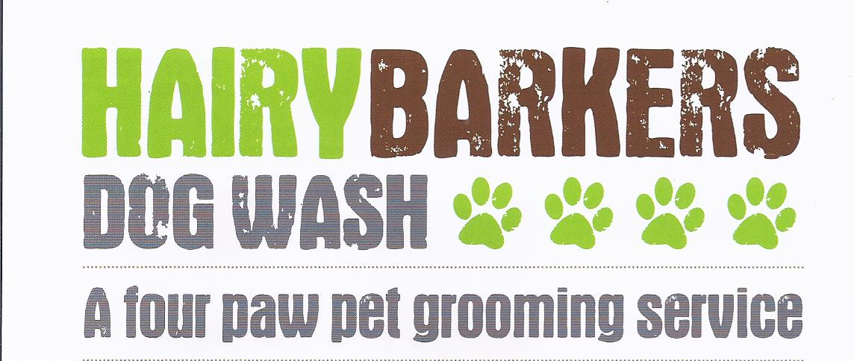

**Issue 3 April 2014**

**NEWSLETTER**

***Helping you keep your pet looking, feeling and smelling great!***

***Tel: 01446 751616 / 07974 720022***

***Website:*** [*www.hairybarkersdogwash.weebly.com*](http://www.hairybarkersdogwash.weebly.com)

***Facebook:***[*www.facebook.com/HairyBarkersDogWash*](http://www.facebook.com/HairyBarkersDogWash)

***Twitter:***[*www.twitter.com/HairyBarkers*](http://www.twitter.com/HairyBarkers)

**1 April – 5 May**

Supporting responsible pet ownership. Find out how you can get involved and be a part of it, at

[**www.nationalpetmonth.org,uk**](http://www.nationalpetmonth.org,uk/)

**\*\*\*\*\*\*\*\*\*\*\*\*\*\*\*\*\*\*\*\*\*\*\*\*\*\*\*\*\*\*\*\*\*\*\*\*\*\*\*\*\*\***

**Matting**

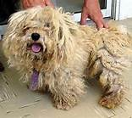Some coat types get matted and tangled easier than others. Fine coated breeds such as Bichons, Poodles, Cockers and Schnauzers can get matts that are very difficult to brush out. Drop coated breeds such as Shih Tzus, Lhasas and Malteses have a similar problem. Goldens, Shepherds and Border Collies have target areas that matt, these being the longer areas around the rump and behind the ears. Heavily shedding breeds will have dead coat packed into the guard coat that can, in most cases easily be removed during the shedding season with the correct tools. Other factors that cause matting are dirt, which literally holds the hair shafts together, static can also cause coats to tangle more easily. Moisture of any type, bathing, dew in the grass, a romp in the snow or swimming can make mats impossible to remove in some coat types, if allowed to dry without brushing or blow-drying. Friction areas behind the ears, front legs and inner thigh areas, tails, and collar areas are likely areas for matts to form. Compression matts are common in pets that are inactive and spend a lot of time lounging. It is common to find one hip or side of the pet more tangled than the other as most pets are right or left sided just like people.

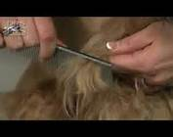If the correct bathing, drying and brushing techniques fail to remove stubborn tangles or the matting is too extensive the only humane thing to do is to shave them off and let the coat grow out again. Most owners want the best for their pet and would never want to hurt their family friend. My first concern is always for the pet and I put humanity before vanity. Proper at home maintenance is a must for longer coated breed and I am always happy to advise owners on how to take care of their pets coat. Alternatively you can always visit Hairy Barkers between grooms for a brush out if you really can’t learn to appreciate your pet in a short, low maintenance cut!

_________________________

**Dog Quotes**

‘A dog wags his tail with his heart’'

___________________________

**Tel/Fax: 01446 751616**

**Mobile: 07974 720022**

***FEATURED PET OF THE MONTH***

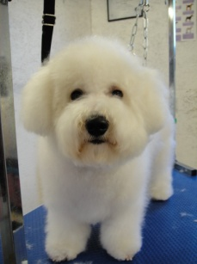***Jac*** the Bichon Frise has been a regular at Hairy Barkers since puppyhood. His owner likes to keep him in full coat with just a face and feet tidy. As they don’t drive, Jac is collected from his home and returned after his groom, looking, feeling and smelling great!

If your pet has longer hair, proper daily brushing is not just a recommendation, it's a necessity.



GROOMING TIPS

**Olive Oil**

It's good for your pets too!  A teaspoon of olive oil added to one of your dog's daily meals will help to make his coat glossy and will also help strengthen his nails.

***Spring Fever? Cool Off with 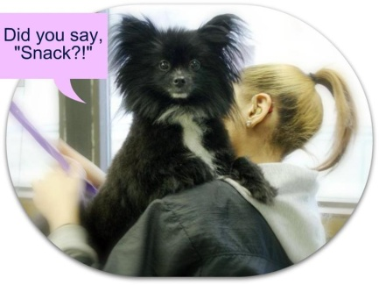Doggie Ice Cream!!***

**Ingredients:**

2 cups vanilla yogurt

1 mashed banana

2 tablespoons honey

2 tablespoons smooth peanut butter

**Directions:**

Combine ingredients.  Mix well.

Freeze overnight in an ice cube tray.

Serve ice cream cubes plain or with a little peanut butter.

**___________________________________________________________________________**

**WALKING WEATHER IS FINALLY HERE**

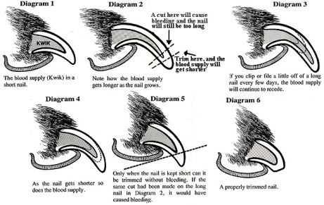Here are some tips to help make your walks more fun and enjoyable for both you and your pet.

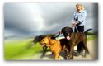

**Start Slow**

We may need a little "warm up" before we get back into our walking routine.  Take a few shorter walk at first, just to make sure your pet is healthy enough for renewed activity.

**A Manicure Wouldn't Hurt**

Keep your dog's nails trimmed so that they don't "click" when they walk.  When nails get too long, they are difficult and uncomfortable to walk on - and may even contribute to joint and back pain.  Free nail trim included in our Wash & Go Service throughout May.  We can even file your pets nails to keep them smoother and shorter.

***HAIRY BARKERS DOG WASH***

***Tel: 01446 751616 / 07974 720022***

***Website:*** [*www.hairybarkersdogwash.weebly.com*](http://www.hairybarkersdogwash.weebly.com)

***Facebook:***[*www.facebook.com/HairyBarkersDogWash*](http://www.facebook.com/HairyBarkersDogWash)

***Twitter:***[*www.twitter.com/HairyBarkers*](http://www.twitter.com/HairyBarkers)

***Helping you keep your pet looking, feeling and smelling great!***

**Safety First!**

It's heartbreaking when we get those calls from frightened owners who have a pet that has gotten loose.  The pets are most often found right away and return home tired and unharmed, but until they are safely home, it's agony wondering if they're hurt or worse.  Keeping your pet on a good leash with a properly fitted collar is the simplest thing you can do to help prevent a lost pet.

**Hairy Barkers is proud to have you as a valued customer and looks forward to seeing you again soon. Louise**

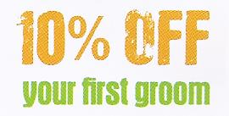

**‘For beautiful grooming, performed with kindness and respect’**

**CALL Louise to arrange your appointment today**

**01446 751616**

**07974 720022**

**For the latest news and offers LIKE OUR FACEBOOK PAGE**

**www.facebook.com/HairyBarkersDogWash**



**Nail Trimming Guide**